Annual Staff Meeting Report -2018
Held at SJDT, Genguvarpatti from 28.04.18 to 30.04.18

“I can hardly wait for tomorrow, it means a new life for me each and every day.”
― Stanley Kunitz

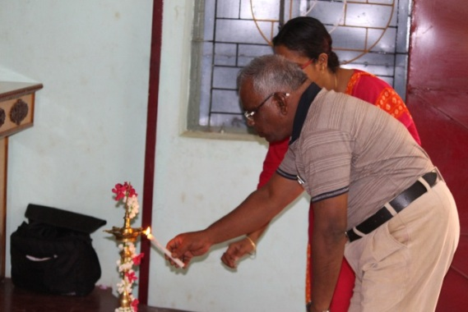
Day 1 (28.04.18, Saturday):
The new and first day of our meeting began on this day. The resource person was Bro. Joseph Fernando who has vast experience in leading group both in national and international level. The participants were all excited to get insights and knowledge from him and renew our spirit as we are going to begin our new academic year.
Our Executive Director Lighting the Lamp
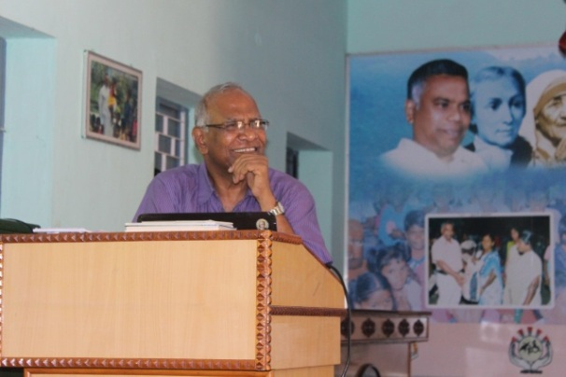
At the outset the day was started with lighting of the lamp. It was lit by five persons namely Dr.I.Sebastian, The Executive Director, Ms. Devi Bala, Sr. Libiya, Mr. Bakiyaraj and Ms. Mariyal. After this, Bro. Joseph Fernando led the prayer service to begin the day. It was indeed very meaningful and very soothing to start the day. Our minds and hearts were energized after this event and we were all set ready for the day’s first session. After the prayer service the Executive Director introduced the resource person to the participants. He has worked as the President of De La Salle Brothers in India for several years. He also has international experience to his credit.
Bro. Joseph Fernando, the Resource Person
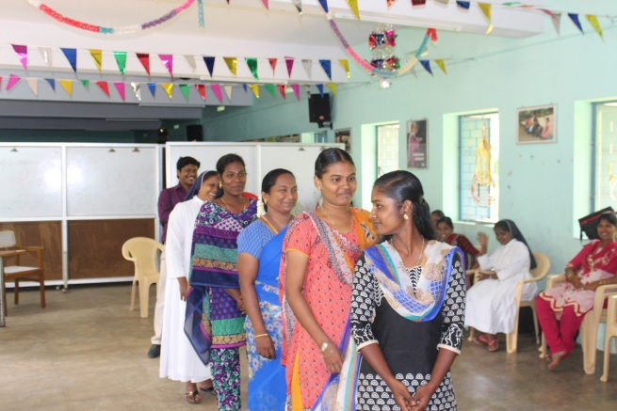
He started of the session with a short and meaningful fun game. It was all about the communication. A group of participants were asked to stand in a line. The last person was asked to turn around and he was told something. The message has to be passed on to the next person without speaking to the other person. In the end when the first person was asked she was not able to grasp even a bit of the message that was conveyed to the last person. Through this exercise he emphasized how important communication skill is. He also mentioned communication is the ability to convey a message to the receiver clearly. Bad communication can definitely cause havocs in our work place. So he advised the participants to learn to listen carefully.
Exercise to Explain the Importance of Communication
After this short introduction and session about communication skill he commenced a new topic and it is about “CHANGE”. He started the session with questions like
Why do I need change?
What am I going to do after changing?
He mentioned change is inevitable in everyone’s life. If one does not change oneself he/she cannot live in this fast growing society. Change does not mean updating knowledge about technology alone but it also includes heart and mind as well. To grow as a better human being we need to the feel of “CHANGE”.
He explained the necessity of change through a story. The story was about an eagle. We are happy to share the story with you the readers as it would certainly inspire anyone who reads it.
“The eagle has the longest life-span among birds. Eagles typically live between 20-30 years in the wild. As apex predators, they are relatively long-lived compared to many other birds. The oldest wild eagle on record is about 32 years of age. It can live up to 70 years. But to reach this age, the eagle must make a hard decision.
In its 40’s its long and flexible talons can no longer grab prey which serves as food. Talons are hard, sharp and curved throughout the eagle’s life. Talons and the beak are made out of keratin, the same material as our fingernails. Think about how long it takes for your nails to grow. Its long and sharp beak becomes bent. An eagle’s beak is hooked to rip and tear its food. It has this distinctive hooked beak throughout its life, like all birds of prey. Beak and talons are critical to eagles’ ability to catch and consume food. No eagle can survive without a beak or talons for any amount of time.
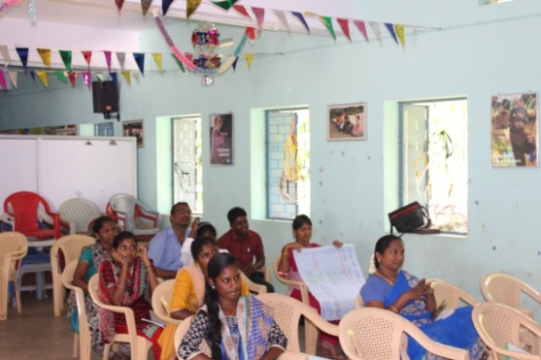
Its old-aged and heavy wings, due to their thick feathers, become stuck to its’ chest and make it difficult to fly. Feathers are replaced throughout an eagle’s life. The process is called molting. An eagle does not lose all of its feathers at one time. It is a gradual process, continually renewing the feathers. Then the eagle is left with only two options: DIE or go through a painful process of change which lasts 150 days. The process requires that the eagle fly to a mountain top and sit on its nest. An eagle’s nest is used only for the rearing of the young. Eagles do not use their nest except for the few months of the year when they are actively raising their young.
Participants Listening to the Resource Person Eagerly
There the eagle knocks its’ beak against a rock until it plucks it out. Beak and talons are critical to eagles’ ability to catch and consume food. No eagle can survive without a beak or talons. When its new talons grow back, the eagle starts plucking its’ old-aged feathers. An eagle cannot survive without food for anything close to 150 days. A few days without food might be possible, but no longer.
And after five months, the eagle takes its’ famous flight of rebirth and lives for 30 MORE YEARS
He also shared another story of eagles. When it rains all the other birds fly towards their nests or look for some safe place to hide from the rain. But the eagles fly high above the clouds and they look at rain from distance place. Through this story he asked the participants to look at the problem from distance place and overcome the problem instead of hiding from it. Soon or later we will face the problem and thus we need to grow in capacity to overcome them. He also urged the participants to think out of the box. Often times we are carried with the crowd like sheep. We hardly think on our own and try to find some new solutions to the problems. He explained with the new exercise. It was indeed different experience for many of us and many of us thought in the routine way as everyone does. People who think out of the box can be successful people and can easily overcome the problems.

Agents of effective change:
- Come up with creative solutions
- Maintaining your creativity long term
- Coming up with other people creatively

Self-worth:
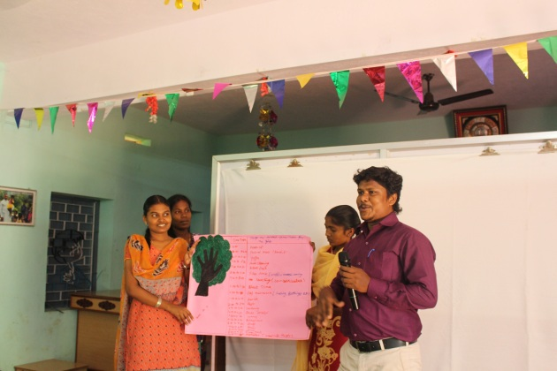
The next session was about self-worth. He gave a lot of emphasis on this topic as some of us have low self-esteem of oneself and have some inferiority complex. The story is shared here for your perusal.
An Exercise to Prepare Holiday Time Table considering the growth of the Children
A well-known speaker started off his seminar by holding up a $20 bill. In the room of 200, he asked. "Who would like this $20 bill?"Hands started going up. He said, "I am going to give this $20 to one of you - but first, let me do this." He proceeded to crumple the 20 dollar note up. He then asked. "Who still wants it?" Still the hands were up in the air."Well," he replied, "what if I do this?" He dropped it on theground and started to grind it into the floor with his shoe. He picked it up, now crumpled and dirty. "Now, who still wants it?" Still the hands went into the air.
"My friends, you have all learned a very valuable lesson. No matter what I did to the money, you still wanted it because it did not decrease in value. It was still worth $20. Many times in our lives, we are dropped, crumpled, and ground into the dirt by the decisions we make and the circumstances that come our way. We feel as though we are worthless; but no matter what happened or what will happen, you will never lose your value. Dirty or clean, crumpled or finely creased, you are still priceless to those who love you. The worth of our lives comes, not in what we do or who we know, but by ...WHO WE ARE.
You are special - don't ever forget it."

The story and his explanation was certainly a boost for all the participants. We could feel that we do have certainly something good in us. There can be misunderstandings, failures and struggles in our workplace, relationship, home and etc. but we should never lose our self-worth.
Johari Window and Abraham Maslow’s Hierarchy of needs:
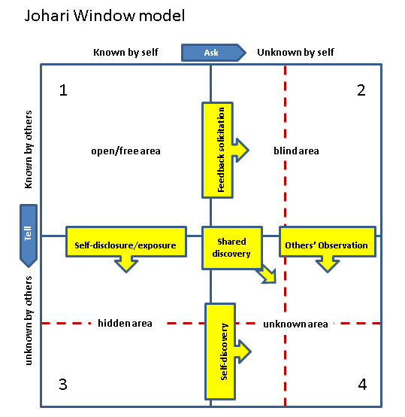
These two models have helped us to recognize our self-worth and the areas we need to work on in order to become even better person. The Johari window is a technique that helps people better understand their relationship themselves and others. This is very vital as the staffs here always dealing with children. So it is quite important that they know their capacity and talents and how they could be used for the welfare of the others maintaining good relationship with the children whom they handle daily.
Maslow’s Hierarchy of Needs

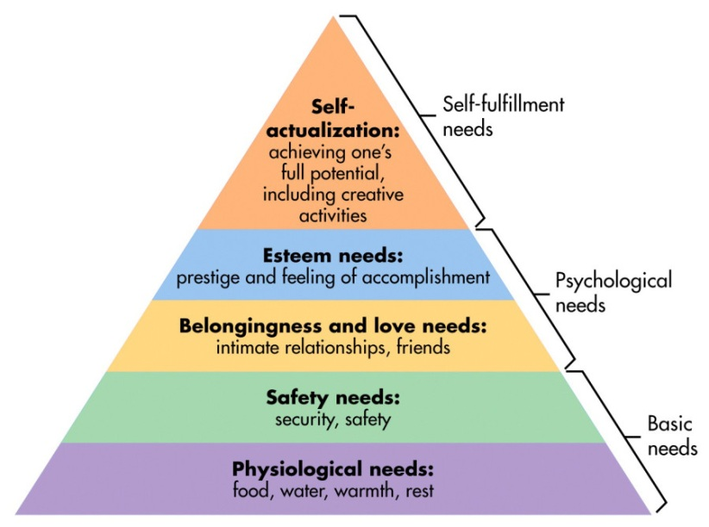

Maslow’s hierarchy is described as follows:
1. Physiological needs, such as needs for food, sleep and air.
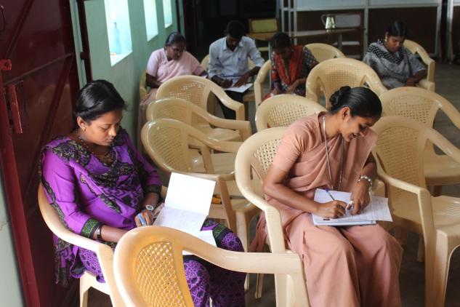
2. Safety, or the needs for security and protection, especially those that emerge from social or political instability.
Participants Analyze themselves to Find Their Inner Strengths
3. Belonging and love including, the needs of deficiency and selfish taking instead of giving, and unselfish love that is based upon growth rather than deficiency.
4. Needs for self-esteem, self-respect, and healthy, positive feelings derived from admiration.
5. And “being” needs concerning creative self-growth, engendered from fulfillment of potential and meaning in life.
The process is continuous but actualization is possible. “Self-actualization” represents a concept derived from Humanisticpsychological theory and, specifically, from the theory created by Abraham Maslow. Self-actualization, according to Maslow, represents growth of an individual toward fulfillment of the highest needs; those for meaning in life, in particular. It was Maslow who created a psychological hierarchy of needs, the fulfillment of which theoretically leads to a culmination of fulfillment of “being values”, or the needs that are on the highest level of this hierarchy, representing meaning.
Maslow’s hierarchy reflects a linear pattern of growth depicted in a direct pyramidal order of ascension. Moreover, he states that self-actualizing individuals are able to resolve dichotomies such as that reflected in the ultimate contrary of free-will and determinism. He also contends that self-actualizers are highly creative, psychologically robust individuals.
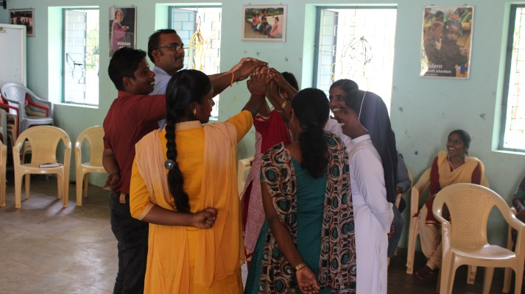
These two topics, Johari window and Maslow’s hierarchy of needs, emphasized us to realize our real self and reach highest point of self-actualization. The participants could understand the importance of growing in knowing oneself which eventually leads us to know others better. We deal with children every day and thus it is very much important to know ourselves in order to lead others.
A Game to Emphasis Unity is Strength
These were the points discussed on day one and in the evening there was one to one sharing session about oneself. The presenter asked the participants to have patient listening to the words of our partner so that our partner feels listened.
DAY 2 (29.04.18 – Sunday):

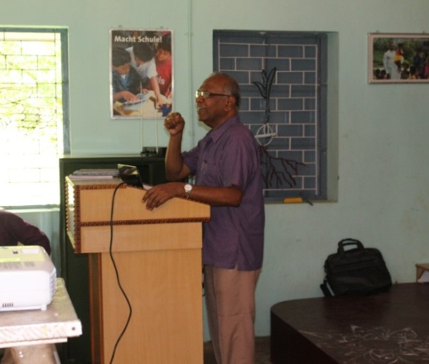
The resource person himself organized the prayer service in the morning before beginning the session. Sr. Libiya had read the Gospel of the day. It was about the vine and its branches. Then the presenter gave a short reflection about the Gospel and how it can be applied in our lives. On completing his reflection the young participants were invited to light the lamp. As the culmination of the prayer service a prayer song was played and with that the prayer service was ended.
The Presenter Presenting the Session
Next Bro. Joseph Fernando introduced the topics which he was going to deal on this day. The topics will be Self-esteem and Self-confidence. He started the topics with sayings from great personalities. One of them was
“The future belongs to those who believe in the beauty of their dreams”- Eleanor Roosevelt
The resource person started motivating the participants to have a dream of our own. He also urged us to get rid of our negative thoughts and inferiority complex about ourselves. Then he went on giving tips to develop our self-esteem. There are twelve tips and they are given below.
- Visualization– Think of our positive and negative and dream what you want to become.
- Self-Analysis – Must make constructive alterations in oneself
- Choose your battles – Match your talents with your goal
- Be objective – Knowing your limitations ( Looking this as it is)
- Build on success – accept little success and appreciation and build on it.
- Be persistent/consistent – Don’t give but keep going; success is not an overnight process.
- Expect some failures – Along the road to success there will be many failures
- Trust your own value system – We have to believe our own values and we are good at it.
- Avoid criticism – Know your faults and strive to change them
- Stay positive – Tell yourself while something may be tough, you can handle it. Associate yourself with other positive people.
- Don’t compare your life to others’ lives – Each one of us is unique in this world and no one can replace me.
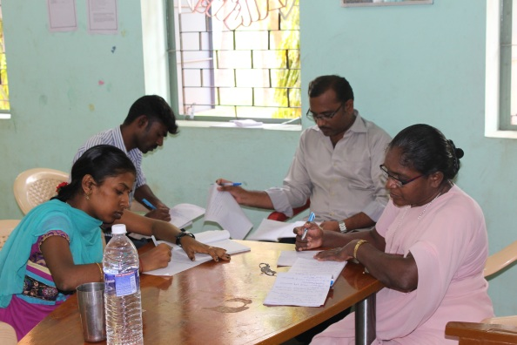
- Renew your self-esteem each day – This self-esteem has to be rejuvenated every day before achieving it completely.
Group Work to Describe a Leader and Leadership

Then Bro. Joseph Fernando began next topic namely “Self Confidence”. He again started the topic with the saying and it was “There is nothing more powerful than those who are unafraid.” After elaborate narration and explanation he summed up in 10 principles of self-confidence
- The importance of self-confidence in our lives cannot be overstated.
- Self-confidence redirects our lives (Confidence is like muscle. The more you use it the stronger it gets)
- Stop comparing yourself
- Celebrate your uniqueness
- Focus on the positives
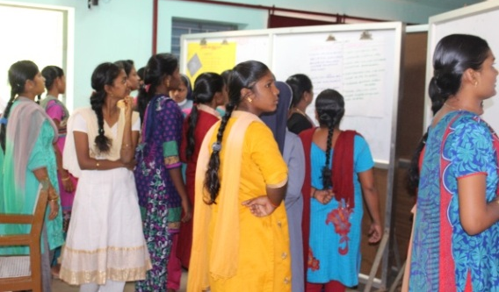
- See past failures as learning opportunities
- Help someone else
- Begin realizing a life goal
- Accept your weakness
- Be known and loved – Fully known and deeply loved
The Participants Viewing Other Groups' Work

He also explained about the lesson of not listening to un-necessary criticism through a short video of a frog. We will get criticism from every side but it is I who decide what to listen and what not to.
The second day came to an end bit early as some of the participants have to attend Eucharistic celebration. The day was indeed very interesting and the topics were dealt on this was once again very essential for all our lives.

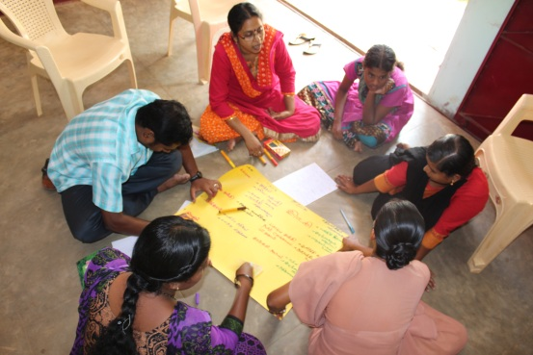
DAY 3 (30.04.18 – Monday):
Once again the day was started with a prayer led by the resource person himself. The Gospel reading was read by Ms. Mariyal on this day. The reading was about leadership. Once the prayer was over Bro. Joseph asked all the participants to write what they think about a leader and what leadership is. Then he asked the same work to be done in groups and the work was presented for all to view.
Group Discussion to Provide Health Food for Children
On finishing the exercise he began the class explaining what a leadership is and how one can be an effective leader. He also shared and compared seven qualities of an eagle with a leader. Those seven leadership skills are described below:
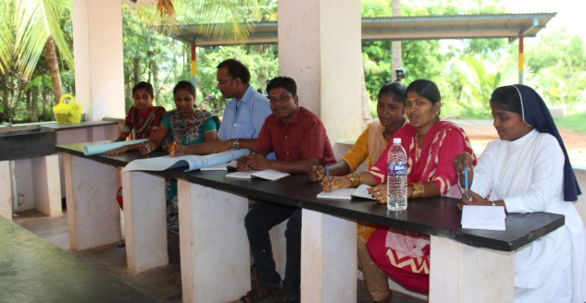
- Stay away from narrow minded people, those that bring you down. Keep good company
Preparing a Short Skit to Explain Leadership
- Have a vision and remain focused regardless of the obstacles and you will succeed.
- Don’t rely on your past accomplishment; keep looking for frontiers to conquer
- Achievers are not afraid of challenges, rather they relish them and use them for profitability
- Whether it’s your personal or professional life one should test the commitment of the people intended for partnership
- Leave your comfort zone because there is no growth.
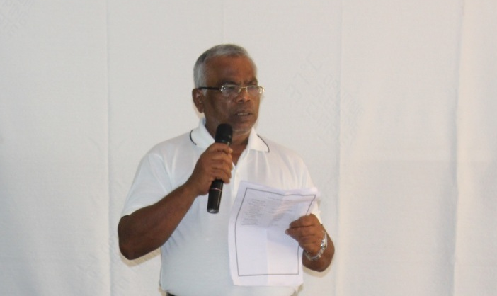
- We occasionally shed off the old habits. Things that burden us or add no values to our lives should be let go.
Time to Thank

The day was wounded by lunch and everyone enjoyed these three days seminar. It meant a lot to all the participants as it enabled everyone to think about themselves a lot. The sessions were kind of orientation to know themselves but it should not be stopped right here rather it is to be continued in their lives in the coming years. The spirit for doing it has to be renewed every day. We need to understand ourselves in order to understand others better. We are very sure that these classes has triggered a kind of spirit in all of us which is going to have ripple effect in our lives and in the lives of the children whom we will be dealing with.

